**CSE 508 Term Project**

**Spring, 2014**

**nftables on Android**

**Completed Tasks**

**Task 1: Port nftables (both kernel -level modules and user- space utilities) and its required kernel support to Android Goldfish 3.10**

**Task 2: Add full packet recording capability (enqueue packets to a user- space program to achieve asynchronous operations)**

**Task 3: Create a new packet selector that matches "sender" and "receiver" of a packet with a given app name (or fully qualified ID)**

**Task 4: Realize a simple per -app traffic profiler, which breaks down the inbound and outbound traffic statistics by (remote_ip, remote_port)**

**Task 5: Create a new action, which replaces the Destination (i.e., redirection) and /or source fields (i.e., source spoofing) of matched packets with given addresses**

**-----------------------------------------------**

**Task 1: Port nftables (both kernel -level modules and user- space utilities) and its required kernel support to Android**

**USER SPACE UTILITIES**

First part is to setup the Andriod NDK, make a new tool-chain, and compile the required libraries with the tool-chain.

**NDK SETUP**

The NDK is a toolset that allows you to implement parts of your app using native-code languages such as C and C++.

COMMANDS

export NDK=~/usr/android-ndk-r8b

export NDK_TOOLCHAIN=${NDK}/toolchains/x86-4.6/prebuilt/linux-x86/bin/i686-linux-android-

export NDK_SYSROOT=${NDK}/platforms/android-9/arch-x86

${NDK_TOOLCHAIN}gcc --sysroot=${NDK_SYSROOT} helloworld.c -o helloworld.exe

**DESIGN NEW TOOLCHAIN**

Android NDK provides "toolchains" (set of tools) to carry out your cross-compilation task. This toolchain is different for different Android architectures. For this project, we need to create a toolchain for x86 architecture.

COMMANDS

./android-ndk-r9b/build/tools/make-standalone-toolchain.sh --platform=android-19 --install-dir=/home/ashishtanwer/ndk_standalone --ndk-dir=./android-ndk-r9b --toolchain=x86-4.6

export PATH=/home/ashishtanwer/ndk_standalone/bin:$PATH

**COMPILING LIBMNL**

libmnl is a minimalistic user-space library that provides helpers for parsing, validating, constructing of both the Netlink header and TLVs that are repetitive and easy to get wrong.

COMMANDS

git clone git://git.netfilter.org/libmnl

./autogen.sh

./configure --host=i686-linux-android --prefix=/home/ashishtanwer/ndk_standalone/

make CC=/home/ashishtanwer/ndk_standalone/bin/i686-linux-android-gcc CFLAGS=--sysroot=/home/ashishtanwer/ndk_standalone/sysroot -I/home/ashishtanwer/libmnl/include/ " LDFLAGS="-L/home/ashishtanwer/ndk_standalone/lib -lmnl" libmnl_test

**COMPILING LIBNFTNL**

libnftnl is a userspace library providing a low-level netlink programming interface (API) to the in-kernel nf_tables subsystem. This library is currently used by **nftables**.

COMMANDS

git clone git://git.netfilter.org/libnftnl

./autogen.sh----

./configure --host=i686-linux-android --prefix=/home/ashishtanwer/ndk_standalone/

make LDFLAGS="-L/home/ashishtanwer/ndk_standalone/lib/ -lmnl"

make LDFLAGS="-L/home/ashishtanwer/ndk_standalone/lib/ -lmnl" install

make CC=/home/ashishtanwer/ndk_standalone/bin/i686-linux-android-gcc CFLAGS="--sysroot=/home/ashishtanwer/ndk_standalone/sysroot -I/home/ashishtanwer/libmnl/include/ -I/home/ashishtanwer/libnftnl/include/" LDFLAGS="-L/home/ashishtanwer/ndk_standalone/lib -lmnl -lnftnl" test_libnftnl

**LIBREADLINE**

libreadline is used to read a line after editing.

COMMANDS

cp /usr/share/misc/config.{sub,guess} support/.

export CC=/home/ashishtanwer/ndk_standalone/bin/i686-linux-android-gcc

./configure CC=/home/ashishtanwer/ndk_standalone/bin/i686-linux-android-gcc --host=i686-linux-android --prefix=/home/ashishtanwer/ndk_standalone/lib/

make

make install

**LIBNCURCES**

libncurces provides terminfo format, supports pads and color and multiple highlights and forms characters and function-key mapping

COMMANDS

./configure CC=/home/ashishtanwer/ndk_standalone/bin/i686-linux-android-gcc --host=i686-linux-android --prefix=/home/ashishtanwer/ndk_standalone/lib/

**NFTABLES USERSPACE UTILITY**

**nftables** is the project that aims to replace the existing **{ip,ip6,arp,eb}tables** framework. Basically, this project provides a new packet filtering framework, a new userspace utility and also a compatibility layer for {ip,ip6}tables. **nftables** is built upon the building blocks of the Netfilter infrastructure such as the existing hooks, the connection tracking system, the userspace queueing component and the logging subsystem.

COMMANDS

./configure --host=i686-linux-android --prefix=/home/ashishtanwer/ndk_standalone/ CFLAGS="--sysroot=/home/ashishtanwer/ndk_standalone/sysroot -I/home/ashishtanwer/libmnl/include/ -I/home/ashishtanwer/libnftnl/include/ -I/home/ashishtanwer/libgmp/x86 -I/home/ashishtanwer/ -I/home/ashishtanwer/ndk_standalone/lib/include/readline " LDFLAGS="-L/home/ashishtanwer/ndk_standalone/sysroot/usr/lib -L/home/ashishtanwer/ndk_standalone/lib -lmnl -lnftnl -lreadline -lgmp -nostdlib"

make LDFLAGS="-L/home/ashishtanwer/ndk_standalone/sysroot/usr/lib/ -L/home/ashishtanwer/ndk_standalone/lib -lmnl -lnftnl -lgmp -lreadline -lncurses"

**LIBNFNETLINK**

libnfnetlink is the low-level library for netfilter related kernel/userspace communication. It provides a generic messaging infrastructure for in-kernel netfilter subsystems (such as nfnetlink_log, nfnetlink_queue, nfnetlink_conntrack) and their respective users and/or management tools in userspace.

COMMANDS

./autogen.sh

./configure --host=i686-linux-android --prefix=/home/ashishtanwer/ndk_standalone/

make LDFLAGS="-L/home/ashishtanwer/ndk_standalone/lib/"

make LDFLAGS="-L/home/ashishtanwer/ndk_standalone/lib/" install

**LIBNETFILTER_QUEUE**

libnetfilter_queue is a userspace library providing an API to packets that have been queued by the kernel packet filter.

Features

* receiving queued packets from the kernel nfnetlink_queue subsystem
* issuing verdicts and/or reinjecting altered packets to the kernel nfnetlink_queue subsystem

COMMANDS

./autogen.sh

export PKG_CONFIG_PATH=/home/ashishtanwer/libnfnetlink:/home/ashishtanwer/libmnl

export LIBNFNETLINK_LIBS="/home/ashishtanwer/ndk_standalone/lib"

export LIBNFNETLINK_CFLAGS="/home/ashishtanwer/libnetfilter_queue/include/"

export LIBMNL_LIBS="/home/ashishtanwer/ndk_standalone/lib"

export LIBMNL_CFLAGS="/home/ashishtanwer/libmnl/include/"

./configure --host=i686-linux-android --prefix=/home/ashishtanwer/ndk_standalone/

Make CFLAGS="-I/home/ashishtanwer/libmnl/include/ -I/home/ashishtanwer/libnfnetlink/include/" LDFLAGS="-L/home/ashishtanwer/ndk_standalone/sysroot/usr/lib -L/home/ashishtanwer/ndk_standalone/lib -lmnl -lnfnetlink"

make LDFLAGS="-L/home/ashishtanwer/ndk_standalone/lib/" install

COMPILING TEST CASE

make CC=/home/ashishtanwer/ndk_standalone/bin/i686-linux-android-gcc CFLAGS="--sysroot=/home/ashishtanwer/ndk_standalone/sysroot -I/home/ashishtanwer/libmnl/include/ -I/home/ashishtanwer/libnfnetlink/include/ -I/home/ashishtanwer/libnetfilter_queue/include/" LDFLAGS="-L/home/ashishtanwer/ndk_standalone/lib -lmnl -lnetfilter_queue" nfqnl_test

**KERNEL LEVEL MODULES**

**KERNEL SELECTION**

We have selected the Android kernel Goldfish because goldfish can run on emulators. The steps used to build kernel are as below:

COMMANDS

git clone https://android.googlesource.com/kernel/goldfish.git

git checkout remotes/origin/android-goldfish-3.10

**KERNEL TOOLCHAIN**

We used the Google provided Android Toolchain to build the kernel for the host Linux and target Android x86_64 architecture.

**Tool chaining: arch-vendor-(os-)abi**

COMMANDS

git clone https://android.googlesource.com/platform/prebuilts/gcc/linux-x86/x86/i686-linux-android-4.6

export PATH=$(pwd)/../i686-linux-android-4.6/bin:$PATH

**KERNEL BUILDING**

COMMANDS

export ARCH=x86

export SUBARCH=x86

export CROSS_COMPILE=$(pwd)/../x86_64-linux-android-4.7/bin/x86_64-linux-android-

ls $(pwd)/../x86_64-linux-android-4.7/bin/x86_64-linux-android-*

make ARCH=x86 i386_emu_defconfig

make ARCH=x86 CC="${CROSS_COMPILE}gcc -mno-android" bzImage -j64

make ARCH=x86 CC="${CROSS_COMPILE}gcc -mno-android" modules -j64

**ANDROID DEVELOPER TOOLS**

ADT (Android Developer Tools) is a plugin that offers you access to many features that help you develop Android applications quickly. ADT provides GUI access to many of the command line SDK tools as well as a UI design tool for rapid prototyping, designing, and building of your application's user interface.

**CREATING CUSTOM AVD**

We created custom ADT based on Nexus S with modification to improve performance will processor speed, memory and sdcard size and capability of snapshots.

COMMANDS

android create avd -n my_android4.4 -t 1 --force

**LAUNCHING EMULATOR**

COMMANDS

emulator -avd nexusS -kernel arch/x86/boot/bzImage -show-kernel -verbose

**APPLYING KERNEL PATCHES**

We started with fresh code of Android kernel Goldfish 3.10 and adopted the following patches from the linux kernel source tree as listed below:

|  |  |
| --- | --- |
| [Merge branch 'master' of git://git.kernel.org/pub/scm/linux/kernel/git/pablo/nf](https://git.kernel.org/cgit/linux/kernel/git/torvalds/linux.git/commit/?id=2e99c07fbe9d823147190753b4d762ec1e31202e) | David S. Miller |
| [netfilter: nf_tables: fix nf_trace always-on with XT_TRACE=n](https://git.kernel.org/cgit/linux/kernel/git/torvalds/linux.git/commit/?id=478b360a47b71f3b5030eacd3aae6acb1a32c2b6) | Florian Westphal |
| [Merge branch 'master' of git://git.kernel.org/pub/scm/linux/kernel/git/pablo/nf](https://git.kernel.org/cgit/linux/kernel/git/torvalds/linux.git/commit/?id=f41f03196041f91acad2b6d2b3e1f800aed60100) | David S. Miller |
| [netfilter: nf_tables: fix potential oops when dumping sets](https://git.kernel.org/cgit/linux/kernel/git/torvalds/linux.git/commit/?id=ec2c9935688fbd5eaa7c975e3e21562c3da77363) | Patrick McHardy |
| [Merge branch 'master' of git://git.kernel.org/pub/scm/linux/kernel/git/pablo/nftables](https://git.kernel.org/cgit/linux/kernel/git/torvalds/linux.git/commit/?id=5ff1dd24168c6dda68d72897a847c364581744ae) | David S. Miller |
| [Merge branch 'master' of git://git.kernel.org/pub/scm/linux/kernel/git/pablo/nftables](https://git.kernel.org/cgit/linux/kernel/git/torvalds/linux.git/commit/?id=751fcac19aeb4f10a246c777517f393d7bc7a9a8) | David S. Miller |
| [Merge branch 'master' of git://git.kernel.org/pub/scm/linux/kernel/git/pablo/nftables](https://git.kernel.org/cgit/linux/kernel/git/torvalds/linux.git/commit/?id=9aa28f2b71055d5ae17a2e1daee359d4174bb13e) | David S. Miller |
| [netfilter: x_tables: lightweight process control group matching](https://git.kernel.org/cgit/linux/kernel/git/torvalds/linux.git/commit/?id=82a37132f300ea53bdcd812917af5a6329ec80c3) | Daniel Borkmann |
| [netfilter: select NFNETLINK when enabling NF_TABLES](https://git.kernel.org/cgit/linux/kernel/git/torvalds/linux.git/commit/?id=5f291c2869a08a63dbdc9de3e13ac5f2d5ed8d47) | Eric Leblond |
| [netfilter: nft_exthdr: call ipv6_find_hdr() with explicitly initialized offset](https://git.kernel.org/cgit/linux/kernel/git/torvalds/linux.git/commit/?id=540436c80e5918dd5ed838449e108b1726fc4d68) | Daniel Borkmann |
| [netfilter: nft: add queue module](https://git.kernel.org/cgit/linux/kernel/git/torvalds/linux.git/commit/?id=0aff078d58e1c69139189e45ba5e929c030e8056) | Eric Leblond |
| [netfilter: nf_tables: fix issue with verdict support](https://git.kernel.org/cgit/linux/kernel/git/torvalds/linux.git/commit/?id=e569bdab35fd0d31cecb6b072e95af1834991f9d) | Eric Leblond |
| [Merge git://git.kernel.org/pub/scm/linux/kernel/git/davem/net-next](https://git.kernel.org/cgit/linux/kernel/git/torvalds/linux.git/commit/?id=42a2d923cc349583ebf6fdd52a7d35e1c2f7e6bd) | Linus Torvalds |
| [Merge branch 'master' of git://git.kernel.org/pub/scm/linux/kernel/git/pablo/nftables](https://git.kernel.org/cgit/linux/kernel/git/torvalds/linux.git/commit/?id=f8785c55141d698d988c6a1ffe4530bc7fa6e886) | David S. Miller |
| [Merge branch 'net-next' of git://git.kernel.org/pub/scm/linux/kernel/git/pablo/nftables](https://git.kernel.org/cgit/linux/kernel/git/torvalds/linux.git/commit/?id=da33edccebcc36d387423dcdb557094fbda55994) | David S. Miller |
| [netfilter: nfnetlink: add batch support and use it from nf_tables](https://git.kernel.org/cgit/linux/kernel/git/torvalds/linux.git/commit/?id=0628b123c96d126e617beb3b4fd63b874d0e4f17) | Pablo Neira Ayuso |
| [netfilter: nf_tables: add compatibility layer for x_tables](https://git.kernel.org/cgit/linux/kernel/git/torvalds/linux.git/commit/?id=0ca743a5599199152a31a7146b83213c786c2eb2) | Pablo Neira Ayuso |
| [netfilter: add nftables](https://git.kernel.org/cgit/linux/kernel/git/torvalds/linux.git/commit/?id=96518518cc417bb0a8c80b9fb736202e28acdf96) | Patrick McHardy |
| [netlink: allow large data transfers from user-space](https://git.kernel.org/cgit/linux/kernel/git/torvalds/linux.git/commit/?id=c05cdb1b864f548c0c3d8ae3b51264e6739a69b1) | Pablo Neira Ayuso |

**TESTING NFT FUNCTIONALITY**

After patching the kernel and selecting appropriate modules from the MENUCONFIG. We compiled most of the netfilter utilities as modules and pushes the loadable kernel modules ko (kernel object) to the emulator.

To test the sanity, we created and deleted, filter tables, chains, hooks and rules. We also the packet accepting, packet dropping and queuing test-cases.

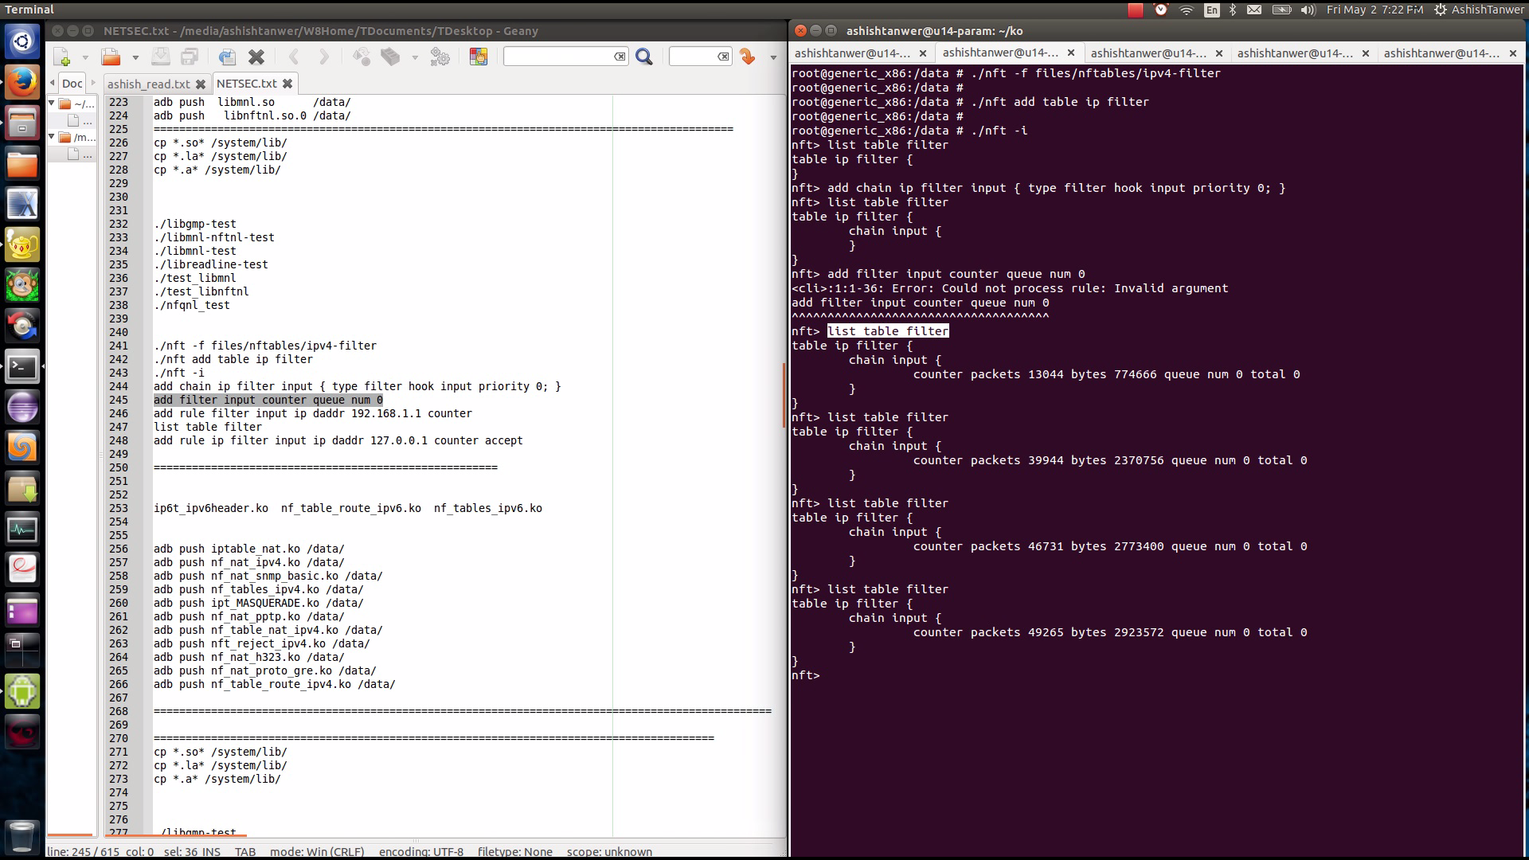

**DROP PACKET RULE TEST**

nft> ^C

130|root@generic_x86:/data # ./nft list table filter -n -a

table ip filter {

chain input {

counter packets 686 bytes 36403 queue num 0 total 0 # handle 2

}

}

root@generic_x86:/data # ./nft delete rule filter input handle 2

<cmdline>:1:1-33: Error: Could not process rule: Invalid argument

delete rule filter input handle 2

^^^^^^^^^^^^^^^^^^^^^^^^^^^^^^^^^

root@generic_x86:/data # ./nft list table filter -n -a

table ip filter {

chain input {

}

}

root@generic_x86:/data # ./nft flush table filter

<cmdline>:1:1-18: Error: Could not process rule: Invalid argument

flush table filter

^^^^^^^^^^^^^^^^^^

<cmdline>:1:1-18: Error: Could not process rule: Invalid argument

flush table filter

^^^^^^^^^^^^^^^^^^

root@generic_x86:/data # ./nft list table filter -n -a

table ip filter {

chain input {

}

}

root@generic_x86:/data # ./nft -f files/nftables/ipv4-filter

root@generic_x86:/data #

root@generic_x86:/data # ./nft add table ip filter

root@generic_x86:/data #

root@generic_x86:/data # ./nft -i

nft>

nft> add chain ip filter input { type filter hook input priority 0; }

nft> add rule ip filter input ip daddr 127.0.0.1 counter drop

<cli>:1:1-56: Error: Could not process rule: Invalid argument

add rule ip filter input ip daddr 127.0.0.1 counter drop

^^^^^^^^^^^^^^^^^^^^^^^^^^^^^^^^^^^^^^^^^^^^^^^^^^^^^^^^

nft> list table filter

table ip filter {

chain input {

ip daddr localhost counter packets 3 bytes 252 drop

}

}

nft> ^C

130|root@generic_x86:/data # ping 127.0.0.1

PING 127.0.0.1 (127.0.0.1) 56(84) bytes of data.

^C

--- 127.0.0.1 ping statistics ---

2 packets transmitted, 0 received, 100% packet loss, time 1017ms

1|root@generic_x86:/data # ./list table filter -n -a

/system/bin/sh: ./list: not found

127|root@generic_x86:/data # ./nft list table filter -n -a

table ip filter {

chain input {

ip daddr 127.0.0.1 counter packets 5 bytes 420 drop # handle 2

}

}

root@generic_x86:/data # ./nft delete rule filter input handle 2

<cmdline>:1:1-33: Error: Could not process rule: Invalid argument

delete rule filter input handle 2

^^^^^^^^^^^^^^^^^^^^^^^^^^^^^^^^^

root@generic_x86:/data # ping 127.0.0.1

PING 127.0.0.1 (127.0.0.1) 56(84) bytes of data.

64 bytes from 127.0.0.1: icmp_seq=1 ttl=64 time=0.170 ms

64 bytes from 127.0.0.1: icmp_seq=2 ttl=64 time=0.082 ms

^C

--- 127.0.0.1 ping statistics ---

2 packets transmitted, 2 received, 0% packet loss, time 999ms

rtt min/avg/max/mdev = 0.082/0.126/0.170/0.044 ms

root@generic_x86:/data # ./nft list table filter

table ip filter {

chain input {

}

}

root@generic_x86:/data #

**Task 2: Add full packet recording capability (enqueue packets to a user- space program to achieve asynchronous operations)**

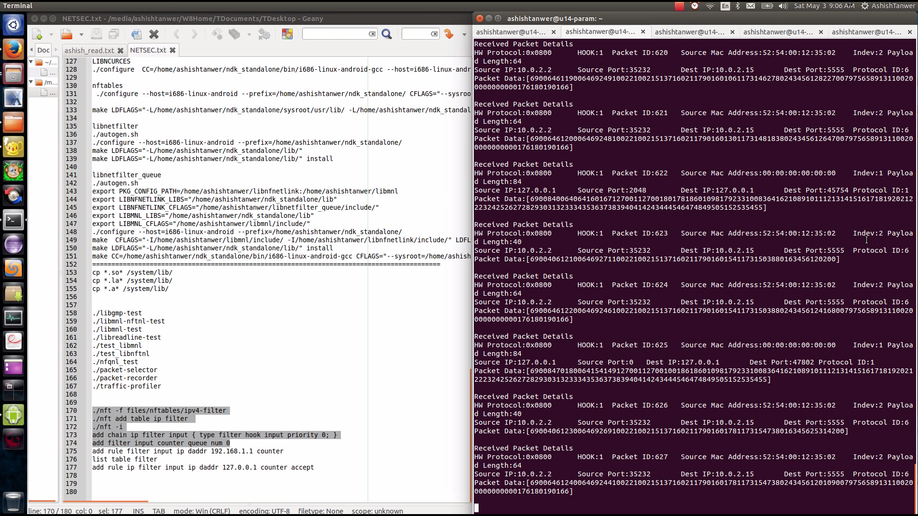

**USERSPACE UTILITY**

#include <stdio.h>

#include <stdlib.h>

#include <unistd.h>

#include <netinet/in.h>

#include <linux/types.h>

#include <linux/netfilter.h> /* for NF_ACCEPT */

#include <arpa/inet.h>

#include <time.h>

#include <libnetfilter_queue/libnetfilter_queue.h>

/* Standard IPv4 header checksum calculation, as per RFC 791 */

u_int16_t ipv4_header_checksum(char *hdr, size_t hdrlen) {

unsigned long sum = 0;

const u_int16_t *bbp;

int count = 0;

bbp = (u_int16_t *)hdr;

while (hdrlen > 1) {

/* the checksum field itself should be considered to be 0 (ie, excluded) when calculating the checksum */

if (count != 10) {

sum += *bbp;

}

bbp++; hdrlen -= 2; count += 2;

}

/* in case hdrlen was an odd number, there will be one byte left to sum */

if (hdrlen > 0) {

sum += *(unsigned char *)bbp;

}

while (sum >> 16) {

sum = (sum & 0xffff) + (sum >> 16);

}

return (~sum);

}

/* returns packet id */

static u_int32_t print_pkt (struct nfq_data *tb)

{

int id = 0;

char p1,p2,p3,p4;

int i =0;

struct nfqnl_msg_packet_hdr *ph;

struct nfqnl_msg_packet_hw *hwph;

u_int32_t mark,ifi;

int ret;

unsigned char *data;

u_int16_t *p_port;

u_int16_t port_s,port_d;

u_int32_t source_ip,dest_ip,*ip_p;

ph = nfq_get_msg_packet_hdr(tb);

if (ph) {

id = ntohl(ph->packet_id);

printf("HW Protocol:0x%04x\tHOOK:%u\tPacket ID:%u\t",

ntohs(ph->hw_protocol), ph->hook, id);

}

hwph = nfq_get_packet_hw(tb);

if (hwph) {

int i, hlen = ntohs(hwph->hw_addrlen);

printf("Source Mac Address:");

for (i = 0; i < hlen-1; i++)

printf("%02x:", hwph->hw_addr[i]);

printf("%02x\t", hwph->hw_addr[hlen-1]);

}

mark = nfq_get_nfmark(tb);

if (mark)

printf("Mark:%u\t", mark);

ifi = nfq_get_indev(tb);

if (ifi)

printf("Indev:%u\t", ifi);

ifi = nfq_get_outdev(tb);

if (ifi)

printf("Outdev:%u\t", ifi);

ifi = nfq_get_physindev(tb);

if (ifi)

printf("Physindev:%u\t", ifi);

ifi = nfq_get_physoutdev(tb);

if (ifi)

printf("Physoutdev:%u\t", ifi);

ret = nfq_get_payload(tb, &data);

if (ret >= 0)

printf("Payload Length:%d", ret);

i=0;

printf("\n");

/* try to get at the actual packet */

p1=*(char *)(data+12);

p2=*(char *)(data+13);

p3=*(char *)(data+14);

p4=*(char *)(data+15);

ip_p=(u_int32_t *)(data+12);

source_ip=(*ip_p);

printf("Source IP:%u.%u.%u.%u\t",p1,p2,p3,p4);

p_port=(u_int16_t *)(data+20);

port_s=ntohs(*p_port);

printf("Source Port:%d\t",port_s);

p1=*(char *)(data+16);

p2=*(char *)(data+17);

p3=*(char *)(data+18);

p4=*(char *)(data+19);

ip_p=(u_int32_t *)(data+16);

dest_ip=(*ip_p);

printf("Dest IP:%u.%u.%u.%u\t",p1,p2,p3,p4);

p_port=(u_int16_t *)(data+22);

port_d=ntohs(*p_port);

printf("Dest Port:%d\t",port_d);

p1=*(char *)(data+9);

printf("Protocol ID:%d\n",p1);

printf("Packet Data:[");

for(i=0;i< ret;i++)

printf("%d",data[i]);

printf("]\n");

i=10000000;

while(i-->0);

fputc('\n', stdout);

return id;

}

static int cb(struct nfq_q_handle *qh, struct nfgenmsg *nfmsg,

struct nfq_data *nfa, void *data)

{

u_int32_t id = print_pkt(nfa);

//printf("entering callback\n");

/* determine the id of the packet in the queue */

/* "accept" the mangled packet */

return nfq_set_verdict(qh, id, NF_ACCEPT, 0, NULL);

}

int main(int argc, char **argv)

{

struct nfq_handle *h;

struct nfq_q_handle *qh;

struct nfnl_handle *nh;

int fd;

int rv;

char buf[4096] __attribute__ ((aligned));

printf("opening library handle\n");

h = nfq_open();

if (!h) {

fprintf(stderr, "error during nfq_open()\n");

exit(1);

}

printf("unbinding existing nf_queue handler for AF_INET (if any)\n");

if (nfq_unbind_pf(h, AF_INET) < 0) {

fprintf(stderr, "error during nfq_unbind_pf()\n");

exit(1);

}

printf("binding nfnetlink_queue as nf_queue handler for AF_INET\n");

if (nfq_bind_pf(h, AF_INET) < 0) {

fprintf(stderr, "error during nfq_bind_pf()\n");

exit(1);

}

printf("binding this socket to queue '0'\n");

qh = nfq_create_queue(h, 0, &cb, NULL);

if (!qh) {

fprintf(stderr, "error during nfq_create_queue()\n");

exit(1);

}

printf("setting copy_packet mode\n");

if (nfq_set_mode(qh, NFQNL_COPY_PACKET, 0xffff) < 0) {

fprintf(stderr, "can't set packet_copy mode\n");

exit(1);

}

fd = nfq_fd(h);

while ((rv = recv(fd, buf, sizeof(buf), 0)) && rv >= 0) {

printf("Received Packet Details\n");

nfq_handle_packet(h, buf, rv);

}

printf("unbinding from queue 0\n");

nfq_destroy_queue(qh);

#ifdef INSANE

/* normally, applications SHOULD NOT issue this command, since

* it detaches other programs/sockets from AF_INET, too ! */

printf("unbinding from AF_INET\n");

nfq_unbind_pf(h, AF_INET);

#endif

printf("closing library handle\n");

nfq_close(h);

exit(0);

}

**EXPERIMENT AND RESULTS**

root@generic_x86:/data # ./nft list table filter

table ip filter {

chain input {

}

}

root@generic_x86:/data # ./nft list table filter

table ip filter {

chain input {

}

}

root@generic_x86:/data # ./nft add filter input counter queue num 0

<cmdline>:1:1-36: Error: Could not process rule: Invalid argument

add filter input counter queue num 0

^^^^^^^^^^^^^^^^^^^^^^^^^^^^^^^^^^^^

root@generic_x86:/data # ./nft list table filter

table ip filter {

chain input {

counter packets 270 bytes 14839 queue num 0 total 0

}

}

root@generic_x86:/data # ./nft delete rule filter input handle 3

<cmdline>:1:1-33: Error: Could not process rule: Invalid argument

delete rule filter input handle 3

^^^^^^^^^^^^^^^^^^^^^^^^^^^^^^^^^

root@generic_x86:/data #

Received Packet Details

HW Protocol:0x0800 HOOK:1 Packet ID:1033 Source Mac Address:52:54:00:12:35:02 Indev:2 Payload Length:40

Source IP:10.0.2.2 Source Port:46324 Dest IP:10.0.2.15 Dest Port:5555 Protocol ID:6

Packet Data:[69004010118006468874100221002151802442117902746357239111149801634561833000]

Received Packet Details

HW Protocol:0x0800 HOOK:1 Packet ID:1034 Source Mac Address:52:54:00:12:35:02 Indev:2 Payload Length:64

Source IP:10.0.2.2 Source Port:46324 Dest IP:10.0.2.15 Dest Port:5555 Protocol ID:6

Packet Data:[6900641011900646884910022100215180244211790274635723911114980243456552540079756589120000700000000000176180190166]

Received Packet Details

HW Protocol:0x0800 HOOK:1 Packet ID:1035 Source Mac Address:52:54:00:12:35:02 Indev:2 Payload Length:40

Source IP:10.0.2.2 Source Port:46324 Dest IP:10.0.2.15 Dest Port:5555 Protocol ID:6

Packet Data:[690040101200064688721002210021518024421179027487572391112008016345618221100]

Received Packet Details

HW Protocol:0x0800 HOOK:1 Packet ID:1036 Source Mac Address:52:54:00:12:35:02 Indev:2 Payload Length:64

Source IP:10.0.2.2 Source Port:46324 Dest IP:10.0.2.15 Dest Port:5555 Protocol ID:6

Packet Data:[6900641012100646884710022100215180244211790274875723911120080243456581790079756589118000600000000000176180190166]

**Task 3: Create a new packet selector that matches "sender" and "receiver" of a packet with a given app name (or fully qualified ID)**

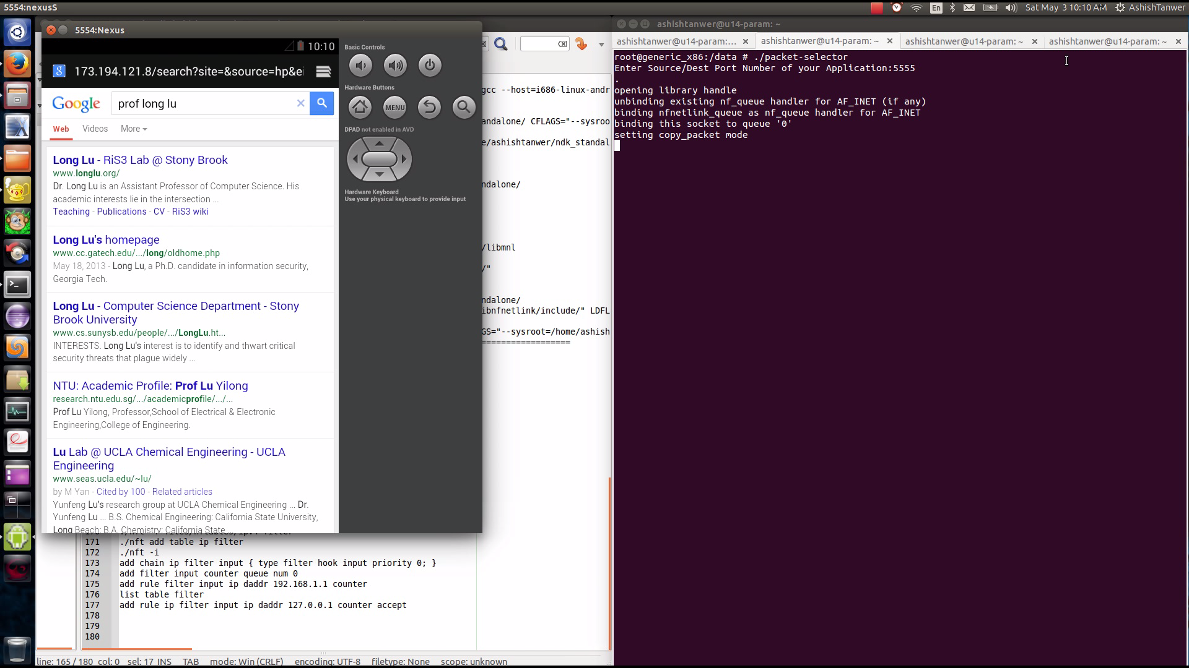

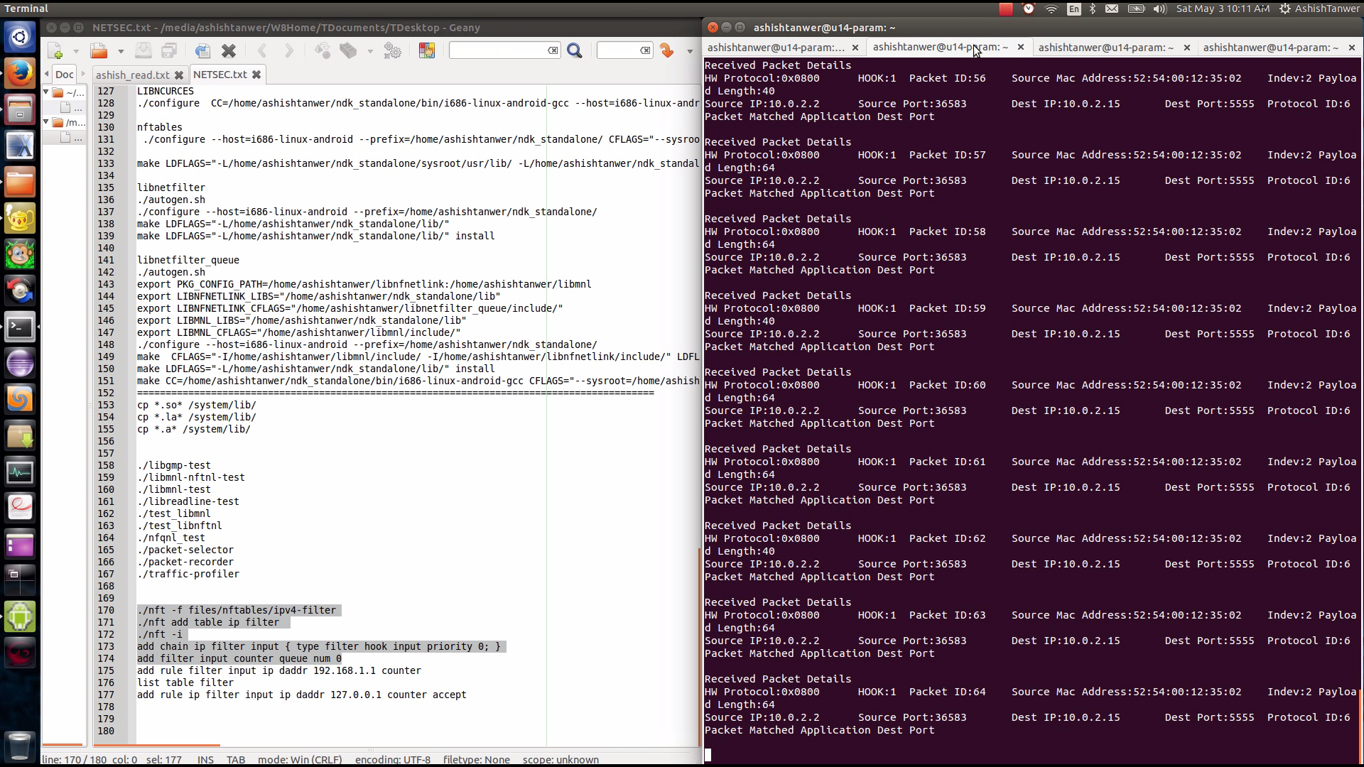

Note: The address 127.0.0.1 on your development machine corresponds to the emulator's own loopback interface. If you want to access services running on your development machine's loopback interface (a.k.a. 127.0.0.1 on your machine), you should use the special address 10.0.2.2 instead.

**Reference:** [**http://developer.android.com/tools/devices/emulator.html**](http://developer.android.com/tools/devices/emulator.html)

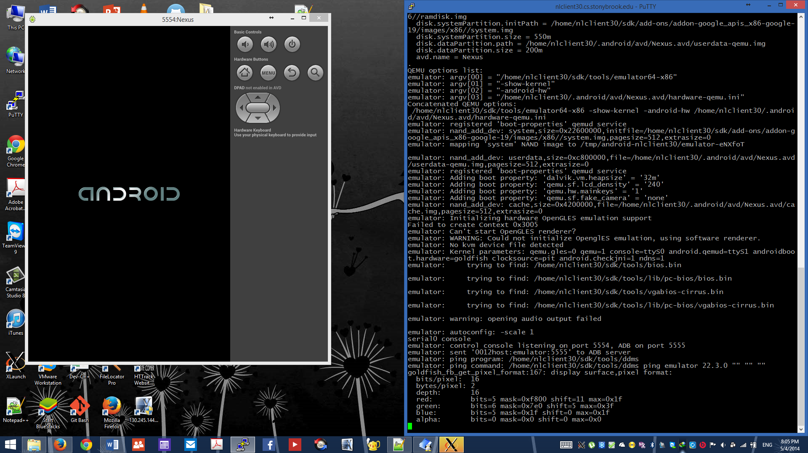

**Note:** The server then sets up connections to all running emulator/device instances. It locates emulator/device instances by scanning odd-numbered ports in the range 5555 to 5585, the range used by emulators/devices.

**Reference:** [**http://developer.android.com/tools/help/adb.html**](http://developer.android.com/tools/help/adb.html)

**We Assumed that app can be identified by specific transport layer port at which it listens for connection. So you can enter your application running port and our packet selector will filter that packet in buffer.**

**USERSPACE UTILITY**

#include <stdio.h>

#include <stdlib.h>

#include <unistd.h>

#include <netinet/in.h>

#include <linux/types.h>

#include <linux/netfilter.h> /* for NF_ACCEPT */

#include <arpa/inet.h>

#include <time.h>

#include <libnetfilter_queue/libnetfilter_queue.h>

struct ip_hdr_prof{

char ip_addr[4];

u_int16_t port_num;

int counter;

};

struct ip_hdr_prof hdr_list[4],*ip_hdr_ptr;

int hdr_list_count=0;

u_int16_t port_num;

/* Standard IPv4 header checksum calculation, as per RFC 791 */

u_int16_t ipv4_header_checksum(char *hdr, size_t hdrlen) {

unsigned long sum = 0;

const u_int16_t *bbp;

int count = 0;

bbp = (u_int16_t *)hdr;

while (hdrlen > 1) {

/* the checksum field itself should be considered to be 0 (ie, excluded) when calculating the checksum */

if (count != 10) {

sum += *bbp;

}

bbp++; hdrlen -= 2; count += 2;

}

/* in case hdrlen was an odd number, there will be one byte left to sum */

if (hdrlen > 0) {

sum += *(unsigned char *)bbp;

}

while (sum >> 16) {

sum = (sum & 0xffff) + (sum >> 16);

}

return (~sum);

}

/* returns packet id */

static u_int32_t print_pkt (struct nfq_data *tb)

{

int id = 0;

char p1,p2,p3,p4;

int i =0;

struct nfqnl_msg_packet_hdr *ph;

struct nfqnl_msg_packet_hw *hwph;

u_int32_t mark,ifi;

int ret;

unsigned char *data;

u_int16_t *p_port;

u_int16_t port_s,port_d;

u_int32_t source_ip,dest_ip,*ip_p;

ph = nfq_get_msg_packet_hdr(tb);

if (ph) {

id = ntohl(ph->packet_id);

printf("HW Protocol:0x%04x\tHOOK:%u\tPacket ID:%u\t",

ntohs(ph->hw_protocol), ph->hook, id);

}

hwph = nfq_get_packet_hw(tb);

if (hwph) {

int i, hlen = ntohs(hwph->hw_addrlen);

printf("Source Mac Address:");

for (i = 0; i < hlen-1; i++)

printf("%02x:", hwph->hw_addr[i]);

printf("%02x\t", hwph->hw_addr[hlen-1]);

}

mark = nfq_get_nfmark(tb);

if (mark)

printf("Mark:%u\t", mark);

ifi = nfq_get_indev(tb);

if (ifi)

printf("Indev:%u\t", ifi);

ifi = nfq_get_outdev(tb);

if (ifi)

printf("Outdev:%u\t", ifi);

ifi = nfq_get_physindev(tb);

if (ifi)

printf("Physindev:%u\t", ifi);

ifi = nfq_get_physoutdev(tb);

if (ifi)

printf("Physoutdev:%u\t", ifi);

ret = nfq_get_payload(tb, &data);

if (ret >= 0)

printf("Payload Length:%d", ret);

i=0;

printf("\n");

/* try to get at the actual packet */

p1=*(char *)(data+12);

p2=*(char *)(data+13);

p3=*(char *)(data+14);

p4=*(char *)(data+15);

ip_p=(u_int32_t *)(data+12);

source_ip=(*ip_p);

printf("Source IP:%u.%u.%u.%u\t",p1,p2,p3,p4);

p_port=(u_int16_t *)(data+20);

port_s=ntohs(*p_port);

printf("Source Port:%d\t",port_s);

p1=*(char *)(data+16);

p2=*(char *)(data+17);

p3=*(char *)(data+18);

p4=*(char *)(data+19);

ip_p=(u_int32_t *)(data+16);

dest_ip=(*ip_p);

printf("Dest IP:%u.%u.%u.%u\t",p1,p2,p3,p4);

p_port=(u_int16_t *)(data+22);

port_d=ntohs(*p_port);

printf("Dest Port:%d\t",port_d);

p1=*(char *)(data+9);

printf("Protocol ID:%d\n",p1);

if(port_num == port_s)

{

printf("Packet Matched Application Source Port\n");

}

else if(port_num==port_d)

{

printf("Packet Matched Application Dest Port\n");

}

/***************************************************************/

i=10000000;

while(i-->0);

fputc('\n', stdout);

return id;

}

static int cb(struct nfq_q_handle *qh, struct nfgenmsg *nfmsg,

struct nfq_data *nfa, void *data)

{

u_int32_t id = print_pkt(nfa);

return nfq_set_verdict(qh, id, NF_ACCEPT, 0, NULL);

}

int main(int argc, char **argv)

{

struct nfq_handle *h;

struct nfq_q_handle *qh;

struct nfnl_handle *nh;

int fd;

int rv;

char buf[4096] __attribute__ ((aligned));

port_num=0;

printf("Enter Source/Dest Port Number of your Application:");

scanf("%d",&port_num);

printf("\n");

printf("opening library handle\n");

h = nfq_open();

if (!h) {

fprintf(stderr, "error during nfq_open()\n");

exit(1);

}

printf("unbinding existing nf_queue handler for AF_INET (if any)\n");

if (nfq_unbind_pf(h, AF_INET) < 0) {

fprintf(stderr, "error during nfq_unbind_pf()\n");

exit(1);

}

printf("binding nfnetlink_queue as nf_queue handler for AF_INET\n");

if (nfq_bind_pf(h, AF_INET) < 0) {

fprintf(stderr, "error during nfq_bind_pf()\n");

exit(1);

}

printf("binding this socket to queue '0'\n");

qh = nfq_create_queue(h, 0, &cb, NULL);

if (!qh) {

fprintf(stderr, "error during nfq_create_queue()\n");

exit(1);

}

printf("setting copy_packet mode\n");

if (nfq_set_mode(qh, NFQNL_COPY_PACKET, 0xffff) < 0) {

fprintf(stderr, "can't set packet_copy mode\n");

exit(1);

}

fd = nfq_fd(h);

while ((rv = recv(fd, buf, sizeof(buf), 0)) && rv >= 0) {

printf("Received Packet Details\n");

nfq_handle_packet(h, buf, rv);

}

printf("unbinding from queue 0\n");

nfq_destroy_queue(qh);

#ifdef INSANE

/* normally, applications SHOULD NOT issue this command, since

* it detaches other programs/sockets from AF_INET, too ! */

printf("unbinding from AF_INET\n");

nfq_unbind_pf(h, AF_INET);

#endif

printf("closing library handle\n");

nfq_close(h);

exit(0);

}

**EXPERIMENT AND RESULTS**

130|root@generic_x86:/data # ./packet-selector

Enter Source/Dest Port Number of your Application:5555

root@generic_x86:/data # ./nft list table filter

table ip filter {

chain input {

}

}

root@generic_x86:/data #

opening library handle

unbinding existing nf_queue handler for AF_INET (if any)

binding nfnetlink_queue as nf_queue handler for AF_INET

binding this socket to queue '0'

setting copy_packet mode

Received Packet Details

HW Protocol:0x0800 HOOK:1 Packet ID:502 Source Mac Address:52:54:00:12:35:02 Indev:2 Payload Length:64

Source IP:10.0.2.2 Source Port:46324 Dest IP:10.0.2.15 Dest Port:5555 Protocol ID:6

Packet Matched Application Dest Port

Received Packet Details

HW Protocol:0x0800 HOOK:1 Packet ID:503 Source Mac Address:52:54:00:12:35:02 Indev:2 Payload Length:40

Source IP:10.0.2.2 Source Port:46324 Dest IP:10.0.2.15 Dest Port:5555 Protocol ID:6

Packet Matched Application Dest Port

Received Packet Details

HW Protocol:0x0800 HOOK:1 Packet ID:504 Source Mac Address:52:54:00:12:35:02 Indev:2 Payload Length:64

Source IP:10.0.2.2 Source Port:46324 Dest IP:10.0.2.15 Dest Port:5555 Protocol ID:6

Packet Matched Application Dest Port

**Task 4: Realize a simple per -app traffic profiler, which breaks down the inbound and outbound traffic statistics by (remote_ip, remote_port)**

Note: We are tracking each connection between different clients and tracking number of packets exchanges between them and displaying the packet count for each pair of remote packet and remote port.

Match Count denoted the number of packets that was exchanged till now over that connection

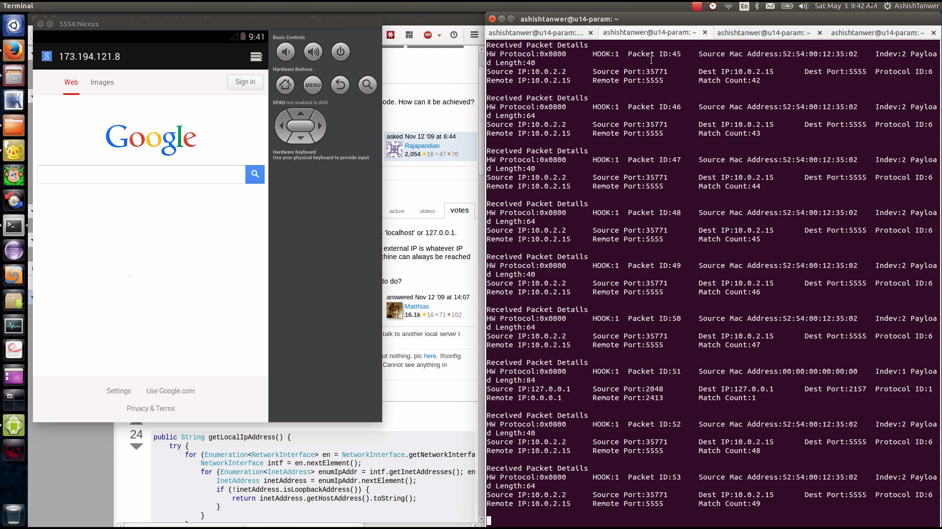

**USERSPACE UTILITY**

#include <stdio.h>

#include <stdlib.h>

#include <unistd.h>

#include <netinet/in.h>

#include <linux/types.h>

#include <linux/netfilter.h> /* for NF_ACCEPT */

#include <arpa/inet.h>

#include <time.h>

#include <libnetfilter_queue/libnetfilter_queue.h>

struct ip_hdr_prof{

char ip_addr[4];

u_int16_t port_num;

int counter;

};

struct ip_hdr_prof hdr_list[1000],*ip_hdr_ptr;

int hdr_list_count=0;

u_int16_t port_num;

/* Standard IPv4 header checksum calculation, as per RFC 791 */

u_int16_t ipv4_header_checksum(char *hdr, size_t hdrlen) {

unsigned long sum = 0;

const u_int16_t *bbp;

int count = 0;

bbp = (u_int16_t *)hdr;

while (hdrlen > 1) {

/* the checksum field itself should be considered to be 0 (ie, excluded) when calculating the checksum */

if (count != 10) {

sum += *bbp;

}

bbp++; hdrlen -= 2; count += 2;

}

/* in case hdrlen was an odd number, there will be one byte left to sum */

if (hdrlen > 0) {

sum += *(unsigned char *)bbp;

}

while (sum >> 16) {

sum = (sum & 0xffff) + (sum >> 16);

}

return (~sum);

}

/* returns packet id */

static u_int32_t print_pkt (struct nfq_data *tb)

{

int id = 0;

char p1,p2,p3,p4;

int i =0;

struct nfqnl_msg_packet_hdr *ph;

struct nfqnl_msg_packet_hw *hwph;

u_int32_t mark,ifi;

int ret;

unsigned char *data;

u_int16_t *p_port;

u_int16_t port_s,port_d;

u_int32_t source_ip,dest_ip,*ip_p;

ph = nfq_get_msg_packet_hdr(tb);

if (ph) {

id = ntohl(ph->packet_id);

printf("HW Protocol:0x%04x\tHOOK:%u\tPacket ID:%u\t",

ntohs(ph->hw_protocol), ph->hook, id);

}

hwph = nfq_get_packet_hw(tb);

if (hwph) {

int i, hlen = ntohs(hwph->hw_addrlen);

printf("Source Mac Address:");

for (i = 0; i < hlen-1; i++)

printf("%02x:", hwph->hw_addr[i]);

printf("%02x\t", hwph->hw_addr[hlen-1]);

}

mark = nfq_get_nfmark(tb);

if (mark)

printf("Mark:%u\t", mark);

ifi = nfq_get_indev(tb);

if (ifi)

printf("Indev:%u\t", ifi);

ifi = nfq_get_outdev(tb);

if (ifi)

printf("Outdev:%u\t", ifi);

ifi = nfq_get_physindev(tb);

if (ifi)

printf("Physindev:%u\t", ifi);

ifi = nfq_get_physoutdev(tb);

if (ifi)

printf("Physoutdev:%u\t", ifi);

ret = nfq_get_payload(tb, &data);

if (ret >= 0)

printf("Payload Length:%d", ret);

i=0;

printf("\n");

/* try to get at the actual packet */

p1=*(char *)(data+12);

p2=*(char *)(data+13);

p3=*(char *)(data+14);

p4=*(char *)(data+15);

ip_p=(u_int32_t *)(data+12);

source_ip=(*ip_p);

printf("Source IP:%u.%u.%u.%u\t",p1,p2,p3,p4);

p_port=(u_int16_t *)(data+20);

port_s=ntohs(*p_port);

printf("Source Port:%d\t",port_s);

p1=*(char *)(data+16);

p2=*(char *)(data+17);

p3=*(char *)(data+18);

p4=*(char *)(data+19);

ip_p=(u_int32_t *)(data+16);

dest_ip=(*ip_p);

printf("Dest IP:%u.%u.%u.%u\t",p1,p2,p3,p4);

p_port=(u_int16_t *)(data+22);

port_d=ntohs(*p_port);

printf("Dest Port:%d\t",port_d);

p1=*(char *)(data+9);

printf("Protocol ID:%d\n",p1);

/***************************************************************/

p1=*(char *)(data+16);

p2=*(char *)(data+17);

p3=*(char *)(data+18);

p4=*(char *)(data+19);

for(i=0;i<hdr_list_count;i++){

ip_hdr_ptr=&hdr_list[i];

if(ip_hdr_ptr->ip_addr[0]==p1 && ip_hdr_ptr->ip_addr[1]==p2 && ip_hdr_ptr->ip_addr[2]==p3 && ip_hdr_ptr->ip_addr[3]==p4 && ip_hdr_ptr->port_num==port_d){

ip_hdr_ptr->counter++;

printf("Remote IP:%u.%u.%u.%u\tRemote Port:%u\nMatch Count:%u\n",(ip_hdr_ptr->ip_addr[0]),ip_hdr_ptr->ip_addr[1],ip_hdr_ptr->ip_addr[2],ip_hdr_ptr->ip_addr[3],ip_hdr_ptr->port_num,ip_hdr_ptr->counter);

break;

}

}

if(hdr_list_count==0 || (!(hdr_list_count==0) && i==hdr_list_count)){

ip_hdr_ptr=&hdr_list[hdr_list_count];

ip_hdr_ptr->ip_addr[0]=p1;

ip_hdr_ptr->ip_addr[1]=p2;

ip_hdr_ptr->ip_addr[2]=p3;

ip_hdr_ptr->ip_addr[3]=p4;

ip_hdr_ptr->port_num=port_d;

ip_hdr_ptr->counter=1;

hdr_list_count++;

printf("Remote IP:%u.%u.%u.%u\tRemote Port:%u\nMatch Count:%u\n",(ip_hdr_ptr->ip_addr[0]),ip_hdr_ptr->ip_addr[1],ip_hdr_ptr->ip_addr[2],ip_hdr_ptr->ip_addr[3],ip_hdr_ptr->port_num,ip_hdr_ptr->counter);

}

i=10000000;

while(i-->0);

fputc('\n', stdout);

return id;

}

static int cb(struct nfq_q_handle *qh, struct nfgenmsg *nfmsg,

struct nfq_data *nfa, void *data)

{

u_int32_t id = print_pkt(nfa);

//printf("entering callback\n");

/* determine the id of the packet in the queue */

/* "accept" the mangled packet */

return nfq_set_verdict(qh, id, NF_ACCEPT, 0, NULL);

}

int main(int argc, char **argv)

{

struct nfq_handle *h;

struct nfq_q_handle *qh;

struct nfnl_handle *nh;

int fd;

int rv;

char buf[4096] __attribute__ ((aligned));

printf("opening library handle\n");

h = nfq_open();

if (!h) {

fprintf(stderr, "error during nfq_open()\n");

exit(1);

}

printf("unbinding existing nf_queue handler for AF_INET (if any)\n");

if (nfq_unbind_pf(h, AF_INET) < 0) {

fprintf(stderr, "error during nfq_unbind_pf()\n");

exit(1);

}

printf("binding nfnetlink_queue as nf_queue handler for AF_INET\n");

if (nfq_bind_pf(h, AF_INET) < 0) {

fprintf(stderr, "error during nfq_bind_pf()\n");

exit(1);

}

printf("binding this socket to queue '0'\n");

qh = nfq_create_queue(h, 0, &cb, NULL);

if (!qh) {

fprintf(stderr, "error during nfq_create_queue()\n");

exit(1);

}

printf("setting copy_packet mode\n");

if (nfq_set_mode(qh, NFQNL_COPY_PACKET, 0xffff) < 0) {

fprintf(stderr, "can't set packet_copy mode\n");

exit(1);

}

fd = nfq_fd(h);

while ((rv = recv(fd, buf, sizeof(buf), 0)) && rv >= 0) {

printf("Received Packet Details\n");

nfq_handle_packet(h, buf, rv);

}

printf("unbinding from queue 0\n");

nfq_destroy_queue(qh);

#ifdef INSANE

/* normally, applications SHOULD NOT issue this command, since

* it detaches other programs/sockets from AF_INET, too ! */

printf("unbinding from AF_INET\n");

nfq_unbind_pf(h, AF_INET);

#endif

printf("closing library handle\n");

nfq_close(h);

exit(0);

}

**EXPERIMENT AND RESULTS**

root@generic_x86:/data # ./nft add filter input counter queue num 0

<cmdline>:1:1-36: Error: Could not process rule: Invalid argument

add filter input counter queue num 0

^^^^^^^^^^^^^^^^^^^^^^^^^^^^^^^^^^^^

root@generic_x86:/data # ./nft delete rule filter input handle 5

<cmdline>:1:1-33: Error: Could not process rule: Invalid argument

delete rule filter input handle 5

^^^^^^^^^^^^^^^^^^^^^^^^^^^^^^^^^

root@generic_x86:/data # ./nft list table filter

table ip filter {

chain input {

}

}

root@generic_x86:/data #

Received Packet Details

HW Protocol:0x0800 HOOK:1 Packet ID:450 Source Mac Address:52:54:00:12:35:02 Indev:2 Payload Length:40

Source IP:10.0.2.2 Source Port:46324 Dest IP:10.0.2.15 Dest Port:5555 Protocol ID:6

Remote IP:10.0.2.15 Remote Port:5555

Match Count:450

Received Packet Details

HW Protocol:0x0800 HOOK:1 Packet ID:451 Source Mac Address:52:54:00:12:35:02 Indev:2 Payload Length:40

Source IP:10.0.2.2 Source Port:46324 Dest IP:10.0.2.15 Dest Port:5555 Protocol ID:6

Remote IP:10.0.2.15 Remote Port:5555

Match Count:451

Received Packet Details

HW Protocol:0x0800 HOOK:1 Packet ID:452 Source Mac Address:52:54:00:12:35:02 Indev:2 Payload Length:88

Source IP:10.0.2.2 Source Port:46324 Dest IP:10.0.2.15 Dest Port:5555 Protocol ID:6

Remote IP:10.0.2.15 Remote Port:5555

Match Count:452

**Task 5: Create a new action, which replaces the Destination (i.e., redirection) and /or source fields (i.e., source spoofing) of matched packets with given addresses**

Through above utilities we have received the packet, Now we have to match the packets 🡪 change it 🡪 pass it to kernel with decision.

To Reinject the packet to the network, we used nfq_set_verdict function.

After you modify your packet and copy it in new buffer, Use this function to reinject the Packet to the network

nfq_set_verdict(qh, id, NF_ACCEPT, ver_len, ver_buf);

Here

ver_len 🡪 is new packet len

ver_buf🡪 is changed packet buffer

NF_ACCEPT 🡪 The decision we made for the packet   
  
int nfq_set_verdict(struct nfq_q_handle *qh,  
    u_int32_t id,  
    u_int32_t verdict,  
    u_int32_t data_len,  
    const unsigned char *buf  
)  
The last two parameters are for the data to be returned to the network stack  
The key is to NF_ACCEPT the packet and pass the suitably modified packet back to the kernel.

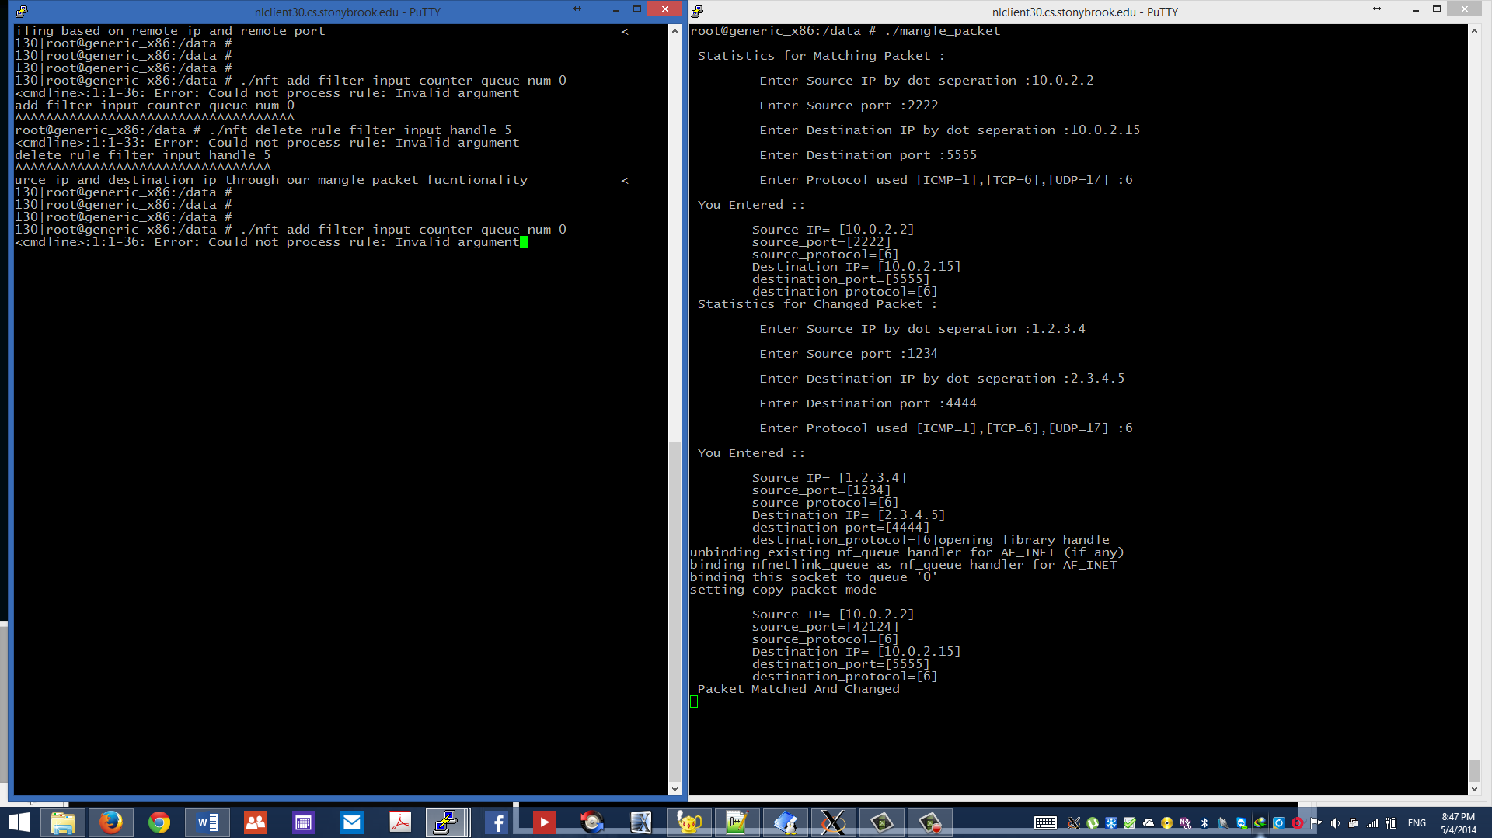

**USERSPACE UTILITY**

#include <stdio.h>

#include <stdlib.h>

#include <unistd.h>

#include <netinet/in.h>

#include <linux/types.h>

#include <linux/netfilter.h> /* for NF_ACCEPT */

#include <arpa/inet.h>

#include <time.h>

#include <libnetfilter_queue/libnetfilter_queue.h>

struct ip_hdr_prof{

char ip_addr[4];

u_int16_t port_num;

char protocol;

int counter;

};

struct ip_hdr_prof match_dest_hdr,match_src_hdr;

struct ip_hdr_prof change_dest_hdr,change_src_hdr;

struct ip_hdr_prof pkt_dest_hdr,pkt_src_hdr;

int hdr_list_count=0;

u_int16_t port_num;

static int cb(struct nfq_q_handle *qh, struct nfgenmsg *nfmsg,

struct nfq_data *nfa, void *data)

{

u_int32_t queue_id;

struct ip_hdr_prof pkt_dest_hdr,pkt_src_hdr;

struct nfqnl_msg_packet_hdr *ph;

int pkt_len;

int i,verdict;

u_int16_t *p_port;

u_int16_t port_s,port_d;

unsigned char *buf;

size_t hdr_len;

ph = nfq_get_msg_packet_hdr(nfa);

if (ph) {

queue_id = ntohl(ph->packet_id);

} else {

return -1;

}*/

/* try to get at the actual packet */

pkt_len = nfq_get_payload(nfa, &buf);

//Packet source ip

pkt_src_hdr.ip_addr[0]=*(char *)(buf+12);

pkt_src_hdr.ip_addr[1]=*(char *)(buf+13);

pkt_src_hdr.ip_addr[2]=*(char *)(buf+14);

pkt_src_hdr.ip_addr[3]=*(char *)(buf+15);

pkt_dest_hdr.ip_addr[0]=*(char *)(buf+16);

pkt_dest_hdr.ip_addr[1]=*(char *)(buf+17);

pkt_dest_hdr.ip_addr[2]=*(char *)(buf+18);

pkt_dest_hdr.ip_addr[3]=*(char *)(buf+19);

p_port=(u_int16_t *)(buf+20);

port_s=ntohs(*p_port);

p_port=(u_int16_t *)(buf+22);

port_d=ntohs(*p_port);

pkt_src_hdr.port_num=port_s;

pkt_dest_hdr.port_num=port_d;

pkt_src_hdr.protocol=*(char *)(buf+9);

pkt_dest_hdr.protocol=*(char *)(buf+9);

printf("\n\tSource IP= [%u.%u.%u.%u]\n\tsource_port=[%d]\n\tsource_protocol=[%d]",pkt_src_hdr.ip_addr[0],pkt_src_hdr.ip_addr[1],pkt_src_hdr.ip_addr[2],pkt_src_hdr.ip_addr[3],pkt_src_hdr.port_num,pkt_src_hdr.protocol);

printf("\n\tDestination IP= [%u.%u.%u.%u]\n\tdestination_port=[%d]\n\tdestination_protocol=[%d]",pkt_dest_hdr.ip_addr[0],pkt_dest_hdr.ip_addr[1],pkt_dest_hdr.ip_addr[2],pkt_dest_hdr.ip_addr[3],pkt_dest_hdr.port_num,pkt_dest_hdr.protocol);

// Match Packets to Change It

if(

(pkt_src_hdr.ip_addr[0]==match_src_hdr.ip_addr[0]) &&

(pkt_src_hdr.ip_addr[1]==match_src_hdr.ip_addr[1]) &&

(pkt_src_hdr.ip_addr[2]==match_src_hdr.ip_addr[2]) &&

(pkt_src_hdr.ip_addr[3]==match_src_hdr.ip_addr[3]) &&

(pkt_dest_hdr.ip_addr[0]==match_dest_hdr.ip_addr[0]) &&

(pkt_dest_hdr.ip_addr[1]==match_dest_hdr.ip_addr[1]) &&

(pkt_dest_hdr.ip_addr[2]==match_dest_hdr.ip_addr[2]) &&

(pkt_dest_hdr.ip_addr[3]==match_dest_hdr.ip_addr[3])

)

{

printf("\n Matched :: Changing Packet According to Provided Details \n");

*(char *)(buf+12)=change_src_hdr.ip_addr[0];

*(char *)(buf+13)=change_src_hdr.ip_addr[1];

*(char *)(buf+14)=change_src_hdr.ip_addr[2];

*(char *)(buf+15)=change_src_hdr.ip_addr[3];

*(char *)(buf+16)=change_dest_hdr.ip_addr[0];

*(char *)(buf+17)=change_dest_hdr.ip_addr[1];

*(char *)(buf+18)=change_dest_hdr.ip_addr[2];

*(char *)(buf+19)=change_dest_hdr.ip_addr[3];

p_port=(u_int16_t *)(buf+20);

*p_port=htons(change_src_hdr.port_num);

p_port=(u_int16_t *)(buf+22);

*p_port=htons(change_dest_hdr.port_num);

*(char *)(buf+9)=change_src_hdr.protocol;

pkt_src_hdr.ip_addr[0]=*(char *)(buf+12);

pkt_src_hdr.ip_addr[1]=*(char *)(buf+13);

pkt_src_hdr.ip_addr[2]=*(char *)(buf+14);

pkt_src_hdr.ip_addr[3]=*(char *)(buf+15);

pkt_dest_hdr.ip_addr[0]=*(char *)(buf+16);

pkt_dest_hdr.ip_addr[1]=*(char *)(buf+17);

pkt_dest_hdr.ip_addr[2]=*(char *)(buf+18);

pkt_dest_hdr.ip_addr[3]=*(char *)(buf+19);

p_port=(u_int16_t *)(buf+20);

port_s=ntohs(*p_port);

p_port=(u_int16_t *)(buf+22);

port_d=ntohs(*p_port);

pkt_src_hdr.port_num=port_s;

pkt_dest_hdr.port_num=port_d;

pkt_src_hdr.protocol=*(char *)(buf+9);

pkt_dest_hdr.protocol=*(char *)(buf+9);

printf("\n Changed Packet");

printf("\n\tSource IP= [%u.%u.%u.%u]\n\tsource_port=[%d]\n\tsource_protocol=[%d]",pkt_src_hdr.ip_addr[0],pkt_src_hdr.ip_addr[1],pkt_src_hdr.ip_addr[2],pkt_src_hdr.ip_addr[3],pkt_src_hdr.port_num,pkt_src_hdr.protocol);

printf("\n\tDestination IP= [%u.%u.%u.%u]\n\tdestination_port=[%d]\n\tdestination_protocol=[%d]",pkt_dest_hdr.ip_addr[0],pkt_dest_hdr.ip_addr[1],pkt_dest_hdr.ip_addr[2],pkt_dest_hdr.ip_addr[3],pkt_dest_hdr.port_num,pkt_dest_hdr.protocol);

i=10000000;

while(i-->0);

}

new_buf = malloc(pkt_len);

if(new_buf==NULL){

printf("\n malloc returned NULL \n");

verdict = nfq_set_verdict(qh, queue_id, NF_ACCEPT, pkt_len, buf);

}

else{

memcpy(new_buf, buf, pkt_len);

verdict = nfq_set_verdict(qh, queue_id, NF_ACCEPT, pkt_len, new_buf);

}

return verdict;

}

int main(int argc, char **argv)

{

struct nfq_handle *h;

struct nfq_q_handle *qh;

struct nfnl_handle *nh;

int fd;

int rv;

char buf[4096] __attribute__ ((aligned));

printf("\n Statistics for Matching Packet :\n");

printf("\n\t Enter Source IP by dot seperation :");

scanf("%d.%d.%d.%d",(int *)&(match_src_hdr.ip_addr[0]),(int*)&(match_src_hdr.ip_addr[1]),(int *)&(match_src_hdr.ip_addr[2]),(int *)&(match_src_hdr.ip_addr[3]));

printf("\n\t Enter Source port :");

scanf("%d",(int *)&(match_src_hdr.port_num));

printf("\n\t Enter Destination IP by dot seperation :");

scanf("%d.%d.%d.%d",(int *)&(match_dest_hdr.ip_addr[0]),(int*)&(match_dest_hdr.ip_addr[1]),(int *)&(match_dest_hdr.ip_addr[2]),(int *)&(match_dest_hdr.ip_addr[3]));

printf("\n\t Enter Destination port :");

scanf("%d",(int *)&(match_dest_hdr.port_num));

printf("\n\t Enter Protocol used [ICMP=1],[TCP=6],[UDP=17] :");

scanf("%d",(int *)&(match_dest_hdr.protocol));

match_src_hdr.protocol=match_dest_hdr.protocol;

printf("\n You Entered ::\n");

printf("\n\tSource IP= [%u.%u.%u.%u]\n\tsource_port=[%d]\n\tsource_protocol=[%d]",match_src_hdr.ip_addr[0],match_src_hdr.ip_addr[1],match_src_hdr.ip_addr[2],match_src_hdr.ip_addr[3],match_src_hdr.port_num,match_src_hdr.protocol);

printf("\n\tDestination IP= [%u.%u.%u.%u]\n\tdestination_port=[%d]\n\tdestination_protocol=[%d]",match_dest_hdr.ip_addr[0],match_dest_hdr.ip_addr[1],match_dest_hdr.ip_addr[2],match_dest_hdr.ip_addr[3],match_dest_hdr.port_num,match_dest_hdr.protocol);

printf("\n Statistics for Changed Packet :\n");

printf("\n\t Enter Source IP by dot seperation :");

scanf("%d.%d.%d.%d",(int *)&(change_src_hdr.ip_addr[0]),(int*)&(change_src_hdr.ip_addr[1]),(int *)&(change_src_hdr.ip_addr[2]),(int *)&(change_src_hdr.ip_addr[3]));

printf("\n\t Enter Source port :");

scanf("%d",(int *)&(change_src_hdr.port_num));

printf("\n\t Enter Destination IP by dot seperation :");

scanf("%d.%d.%d.%d",(int *)&(change_dest_hdr.ip_addr[0]),(int*)&(change_dest_hdr.ip_addr[1]),(int *)&(change_dest_hdr.ip_addr[2]),(int *)&(change_dest_hdr.ip_addr[3]));

printf("\n\t Enter Destination port :");

scanf("%d",(int *)&(change_dest_hdr.port_num));

printf("\n\t Enter Protocol used [ICMP=1],[TCP=6],[UDP=17] :");

scanf("%d",(int *)&(change_dest_hdr.protocol));

change_src_hdr.protocol=change_dest_hdr.protocol;

printf("\n You Entered ::\n");

printf("\n\tSource IP= [%u.%u.%u.%u]\n\tsource_port=[%d]\n\tsource_protocol=[%d]",change_src_hdr.ip_addr[0],change_src_hdr.ip_addr[1],change_src_hdr.ip_addr[2],change_src_hdr.ip_addr[3],change_src_hdr.port_num,change_src_hdr.protocol);

printf("\n\tDestination IP= [%u.%u.%u.%u]\n\tdestination_port=[%d]\n\tdestination_protocol=[%d]",change_dest_hdr.ip_addr[0],change_dest_hdr.ip_addr[1],change_dest_hdr.ip_addr[2],change_dest_hdr.ip_addr[3],change_dest_hdr.port_num,change_dest_hdr.protocol);

printf("opening library handle\n");

h = nfq_open();

if (!h) {

fprintf(stderr, "error during nfq_open()\n");

exit(1);

}

printf("unbinding existing nf_queue handler for AF_INET (if any)\n");

if (nfq_unbind_pf(h, AF_INET) < 0) {

fprintf(stderr, "error during nfq_unbind_pf()\n");

exit(1);

}

printf("binding nfnetlink_queue as nf_queue handler for AF_INET\n");

if (nfq_bind_pf(h, AF_INET) < 0) {

fprintf(stderr, "error during nfq_bind_pf()\n");

exit(1);

}

printf("binding this socket to queue '0'\n");

qh = nfq_create_queue(h, 0, &cb, NULL);

if (!qh) {

fprintf(stderr, "error during nfq_create_queue()\n");

exit(1);

}

printf("setting copy_packet mode\n");

if (nfq_set_mode(qh, NFQNL_COPY_PACKET, 0xffff) < 0) {

fprintf(stderr, "can't set packet_copy mode\n");

exit(1);

}

fd = nfq_fd(h);

while ((rv = recv(fd, buf2, sizeof(buf2), 0)) && rv >= 0) {

// printf("Received Packet Details\n");

nfq_handle_packet(h, buf2, rv);

}

printf("unbinding from queue 0\n");

nfq_destroy_queue(qh);

#ifdef INSANE

/* normally, applications SHOULD NOT issue this command, since

* it detaches other programs/sockets from AF_INET, too ! */

printf("unbinding from AF_INET\n");

nfq_unbind_pf(h, AF_INET);

#endif

printf("closing library handle\n");

nfq_close(h);

exit(0);

}

**EXPERIMENT AND RESULTS**

130|root@generic_x86:/data # ./mangle_packet

Statistics for Matching Packet :

Enter Source IP by dot seperation :10.0.2.2

Enter Source port :2222

Enter Destination IP by dot seperation :10.0.2.15

Enter Destination port :5555

Enter Protocol used [ICMP=1],[TCP=6],[UDP=17] :6

You Entered ::

Source IP= [10.0.2.2]

source_port=[2222]

source_protocol=[6]

Destination IP= [10.0.2.15]

destination_port=[5555]

destination_protocol=[6]

Statistics for Changed Packet :

Enter Source IP by dot seperation :1.2.3.4

Enter Source port :2222

Enter Destination IP by dot seperation :2.3.4.5

Enter Destination port :666

Enter Protocol used [ICMP=1],[TCP=6],[UDP=17] :6

You Entered ::

Source IP= [1.2.3.4]

source_port=[2222]

source_protocol=[6]

Destination IP= [2.3.4.5]

destination_port=[666]

destination_protocol=[6]opening library handle

unbinding existing nf_queue handler for AF_INET (if any)

binding nfnetlink_queue as nf_queue handler for AF_INET

binding this socket to queue '0'

setting copy_packet mode

HW Protocol:0x0800 HOOK:1 Packet ID:1 Source Mac Address:52:54:00:12:35:02 Indev:2 Payload Length:64

Source IP:10.0.2.2 Source Port:46324 Dest IP:10.0.2.15 Dest Port:5555 Protocol ID:6

Packet Data:[6900641610400646826410022100215180244211790215728572431789980243456165780079756589118000600000000000176180190166]

Source IP= [10.0.2.2]

source_port=[46324]

source_protocol=[6]

Destination IP= [10.0.2.15]

destination_port=[5555]

destination_protocol=[6]

Matched :: Changing Packet According to Provided Details

Changed Packet

Source IP= [1.2.3.4]

source_port=[2222]

source_protocol=[6]

Destination IP= [2.3.4.5]

destination_port=[666]

**REFRENCES**

1. <http://www.netfilter.org/projects/libnetfilter_queue/doxygen/nfqnl__test_8c_source.html>
2. <http://cxw06023273.iteye.com/blog/867142>
3. <http://stackoverflow.com/questions/10439956/accepting-packets-in-user-space-from-netfilter>
4. <http://l7-filter.sourceforge.net/>
5. <http://www.netfilter.org/documentation/HOWTO//netfilter-hacking-HOWTO-4.html#ss4.7>
6. <http://cs.uccs.edu/~smanet/aodvsrc/packet_queue.c>
7. <http://stackoverflow.com/questions/10439956/accepting-packets-in-user-space-from-netfilter>
8. <https://android.googlesource.com/platform/prebuilts/gcc/linux-x86/x86/i686-linux-android-4.6>
9. <https://home.regit.org/2014/02/suricata-and-nftables/>
10. <http://comments.gmane.org/gmane.comp.security.firewalls.netfilter.devel/50300>
11. <https://home.regit.org/2011/04/some-new-features-of-ips-mode-in-suricata-1-1beta2/>
12. <https://home.regit.org/tag/nftables/>
13. <http://patchwork.ozlabs.org/patch/307328/>
14. <http://www.spinics.net/lists/netdev/msg264868.html>
15. <http://people.netfilter.org/wiki-nftables/index.php/Queueing_to_userspace>
16. <http://people.netfilter.org/wiki-nftables/index.php/Main_Page>
17. <http://people.netfilter.org/wiki-nftables/index.php/Performing_Network_Address_Translation_(NAT)>
18. <http://git.kernel.org/cgit/linux/kernel/git/torvalds/linux.git/commit/?id=96518518cc417bb0a8c80b9fb736202e28acdf96>